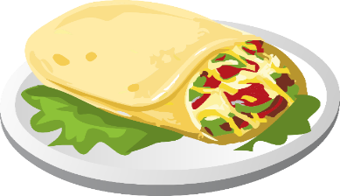
Crawford Bay School
HOT LUNCH MENU
WEEK OF: Jan. 26 - 29

Monday: Spaghetti

Tuesday: Papas Bravas/Potato Nachos

Wednesday: Pizza

**Salad Bar is included with each Hot Lunch**

Prices:
Students K – 4: $4
Students 5 – 7: $5
Students 8 – 12: $6
Parents: $10
Community Members: $12
- Payment can be made via E-transfer (cbess.hotlunch@gmail.com) or cash/cheque at the school office.

