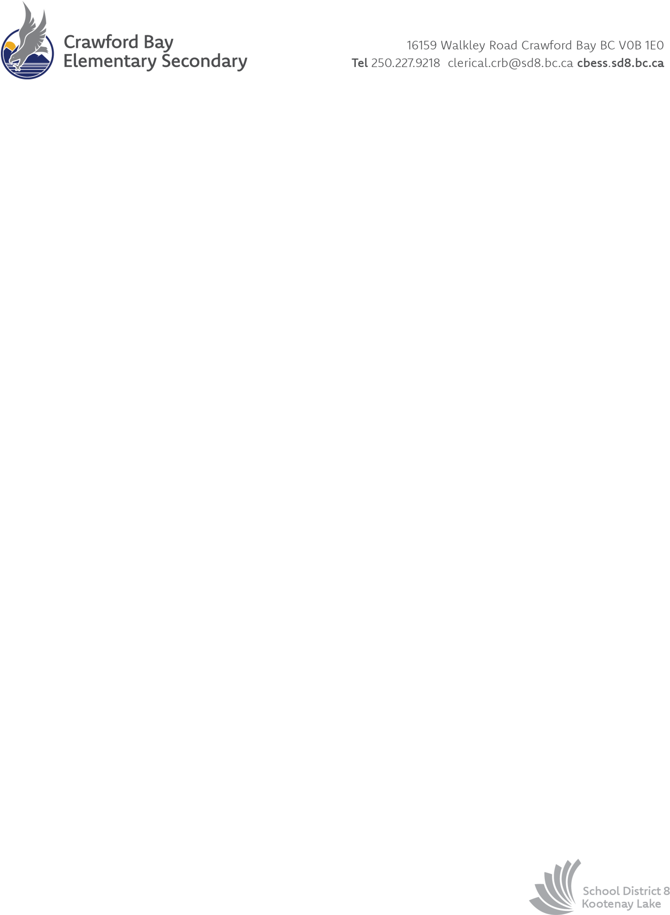

**Grades 7-12**- some students prefer specific materials, and they are welcome to bring those items, but we will have on hand anything students need for their course work.

Some items students choose to bring are an agenda book to track class due dates, preferred pens/pencils/gel pens/markers, a calculator, pencil case, fidget tools to help with focus, specific binder types etc.

**K-12 supplies that families provide (it really helps your child and our staff if you label these):**

* Comfortable **backpack** to hold a sweater, books, snacks, water etc.
* **Water bottle**
* **Indoor running shoes** (with Velcro if your child cannot yet tie their shoes)
* For primary students, please send a bag with an **extra set of clothes** in case a change is needed
* For grades 5+, please send **gym clothes – shorts or sweatpants and an extra shirt,** whatever your child is comfortable playing sports in.

Please bring a cheque or cash to the office within the first 2 weeks of school, or you can pay through our website: <https://cbess.sd8.bc.ca/pay>

If your family would benefit from some financial support in paying these fees or purchasing the items listed below, please reach out to Principal [Victoria McAllister](mailto:%20victoria.mcallister@sd8.bc.ca)

School District 8 [AP 5060: School Fees, Deposits and Financial Hardship](AP%205060:%20School%20Fees,%20Deposits%20and%20Financial%20Hardship) information

**Grades *K-12:***

* + * $45 per student for all school & art supplies, purchased by our school (up to $100 per family).
  + See list below for items to be provided by families.
  + * The actual cost of supplies is more than the fee we seek reimbursement for, but we endeavour to keep costs as low as possible for families.

*Crawford Bay School Supplies and Fees: 2025-2026*

Supplies for families to purchase**:**